**CS 639 Building User Interfaces, *Fall 2019***

# OVERVIEW

### CREDITS

This is a three-credit course.

### CANVAS COURSE URL

<https://canvas.wisc.edu/courses/169115>

### CANVAS WEBSITE

<https://wisc-hci-curriculum.github.io/cs639-f19/>

### COURSE DESIGNATIONS AND ATTRIBUTES

Undergraduate elective in computer science

### MEETING TIME AND LOCATION

Scheduled class time: Tuesdays-Thursdays 1:00–2:15 pm in CS 1221

### INSTRUCTIONAL MODE

Face-to-face

SPECIFY HOW CREDIT HOURS ARE MET BY THE COURSE  
This class meets for two, 75-minute class periods each week over the fall semester and carries the expectation that students will work on course learning activities (reviewing lecture materials, completing weekly assignments) for about 3 hours out of the classroom for every class period. The syllabus includes more information about meeting times and expectations for student work.

### COURSE DESCRIPTION

This course introduces students to the software development of user interfaces (UIs). Topics covered include state-of-the-art (1) UI paradigms, such as event-driven interfaces, direct-manipulation interfaces, and dialogue-based interaction; (2) methods for capturing, interpreting, and responding to different forms of user input and states, including pointing, text entry, speech, touch, gestures, user activity, context, and physiological states; and (3) platform-specific UI development APIs, frameworks, and toolkits for platforms including web/mobile/desktop interfaces, natural user interfaces, and voice user interfaces. Through readings, lectures, and hands-on-activities, students will learn about the fundamental concepts, technologies, and methods in building user interfaces. Assignments will provide an opportunity to gain hands-on experience in the use of state-of-the-art UI development tools and build a UI development portfolio.

### REQUISITES

CS-400

# INSTRUCTORS AND TEACHING ASSISTANTS

### INSTRUCTOR TITLE AND NAME

Associate Professor Bilge Mutlu

Department of Computer Sciences, University of Wisconsin–Madison

1210 W Dayton St, Room 6381, Madison, WI 53706-1685 USA

**Phone:** +1 (608) 262-6635; **E-mail:** [bilge@cs.wisc.edu](mailto:bilge@cs.wisc.edu)

### INSTRUCTOR AVAILABILITY

During scheduled class hours; during office hours (immediately after class, Tuesday-Thursday 2:15–3 pm); or by appointment.

### INSTRUCTOR EMAIL/PREFERRED CONTACT

Preferred contact is face-to-face meeting during office hours or through the course Microsoft Teams.

### TEACHING ASSISTANTS

Andrew Schoen

Hanna Strohm

### TA OFFICE HOURS

See the table below for instructional team office hours.

### TA EMAIL/PREFERRED CONTACT

Please either mention or start a new chat with the peer mentors in Microsoft Teams.

### PEER MENTORS

Mathias Strohkirch

Jeff Ma

### PEER MENTOR OFFICE HOURS

See the table below for instructional team office hours.

### PEER MENTOR EMAIL/PREFERRED CONTACT

Please either mention or start a new chat with the peer mentors in Microsoft Teams.

# CLINICS

Office hours for this course will be in the form of “clinics” that will be open lab hours when the instructional team will be available for drop-ins for questions, code/design reviews, and feedback. All clinics and office hours will be held in the HCI Lab (3351 CS) or the conference room next door (3331 CS). CS Below are the clinic hours for this semester.

|  |  |  |  |  |  |
| --- | --- | --- | --- | --- | --- |
|  | **Monday** | **Tuesday** | **Wednesday** | **Thursday** | **Friday** |
| 1-3 pm | Code clinic: *Mathias* | Class, instructor office hours |  | Class, instructor office hours | Code clinic: *Hanna* & *Jeff* |
| 3-5 pm | Code clinic: *Hanna* | Design clinic: *Andy* | Design Clinic: *Jeff* | Code clinic: *Andy* | Code clinic: *Mathias* |

# LEARNING OUTCOMES

### COURSE LEARNING OUTCOMES

Student will be able to:

* Engage in design thinking around user interface needs and problems, ideate and communicate conceptual design solutions
* Create visual designs, layouts, and navigation structures, and effectively use design languages, color palettes, and platform-specific design elements
* Prototype and develop user interfaces for the Web, mobile, and voice user interfaces (VUIs)
* Program front-end, user-facing software elements using the state-of-the-art programming languages, frameworks, and libraries
* Follow user-centered design principles, heuristics, and methods to iteratively build, assess, and refine design solutions

### COURSE TOPICS

As an introduction to UX development, the course will cover the (1) programming skills you will need to prototype and build user-facing applications and (2) design skills you will need to understand user needs, devise solutions, and test how well they work. The design skills, under the category **design**, are introduced on Tuesdays, and the programming skills, under the category **build**, are introduced on Thursdays. Across three modules, you will focus on **web**, **mobile**, and **voice** interfaces. For each module, we will use the programming framework that is most commonly used in the software development industry. Below is a visual breakdown of the topics.

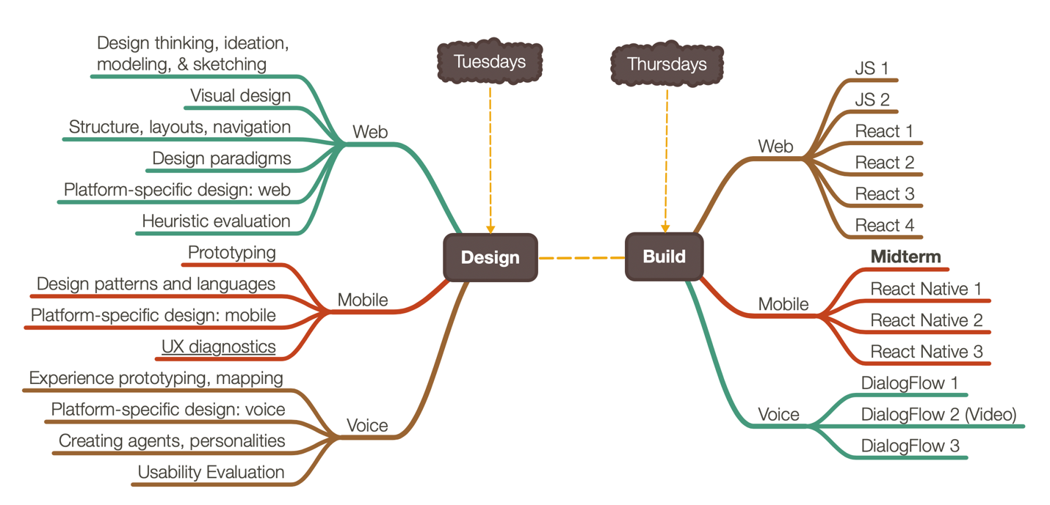

# GRADING

### GRADING WEIGHTS

|  |  |
| --- | --- |
| Assessments | Points |
| Weekly assignments | 50 |
| Midterm | 15 |
| Final | 25 |
| Attendance, classroom participation, quizzes | 10 |
| *Total* | *100* |

### GRADING SCALE

|  |  |  |
| --- | --- | --- |
| A | 93.5–100 | Excellent work *(Exceeds expectations)* |
| AB | 89.5–93.4 | Good work *(Robustly meets all stated requirements)* |
| B | 83.5–89.4 | Adequate work *(Meets the spirit of all stated requirements)* |
| BC | 79.5–83.4 | Slightly below adequate  *(Missing small required elements or turned in late without approved extension)* |
| C | 73.5–79.4 | Below adequate *(Missing required elements or turned in late without approved extension)* |
| D | 73.4–63.5 | Well below adequate *(Missing many required elements or turned in late without approved extension)* |
| F | 63.5 | Inadequate *(Work not turned in, no extension requested)* |

# COURSE STRUCTURE

### WEEKLY ASSIGNMENTS

The majority of student work for the class will involve weekly assignments that incrementally build three user interfaces (web, mobile, voice user interfaces). Students will complete a total of 27 weekly assignments (14 design, 13 build). For build assignments, students will be provided design specifications and starting code that they will build on to design and build their own solutions.

### EXAMS

The class will involve two exams—a midterm and a final—that will make up 40% of the grade. Additionally, quizzes will be given using Top Hat during class.

### REQUIRED TEXTBOOK, SOFTWARE & OTHER COURSE MATERIALS

The instructional content for the class is curated from different books, articles, and multimedia resources. All reading and multimedia material will be provided through the course website PDFs or links to archives or multimedia resources (e.g., YouTube). Similarly, information and tutorials on all necessary tools and software will be provided on the course website. A number of recommended (optional) textbooks are provided for students interested in further study. The course has a number of technology requirements, which are listed on the course website along with lings and information on how to obtain them.

# COURSE POLICIES

### POLICIES FOR COURSE CONDUCT

**Attendance:** All students are required to attend class, and attendance will be taken at each class.

**Late Policy:** Every student will have a total of 5 late days that can be used once toward a single assignment (e.g., submitting an assignment 5 days late) or in parts toward multiple assignments (e.g., submitting 5 assignments 1 day late). In general, it is strongly recommended that you submit your assignment 30 minutes before the deadline to avoid last minute technical difficulties (e.g., network delays). If the deadline is at 11:59 pm, and you submitted at 12:01 am, you will have used one of your late days.

**Emergencies and Exceptions:** Inform the instructor immediately on Microsoft Teams of any crisis that preclude you from attending a class or an exam.

**Special Needs:** Students with special needs should inform the instructor immediately via email so that accommodations can be made.

**Religious observances:** Let the instructor know *well in advance* if an assignment, deadline, or major project milestone interferes with an important religious or cultural observance/event.

### RULES, RIGHTS & RESPONSIBILITIES

See the Guide’s to Rules, Rights and Responsibilities at <http://guide.wisc.edu/undergraduate/#rulesrightsandresponsibilitiestext>.

### ACADEMIC INTEGRITY

By enrolling in this course, each student assumes the responsibilities of an active participant in UW-Madison’s community of scholars in which everyone’s academic work and behavior are held to the highest academic integrity standards. Academic misconduct compromises the integrity of the university. Cheating, fabrication, plagiarism, unauthorized collaboration, and helping others commit these acts are examples of academic misconduct, which can result in disciplinary action. This includes but is not limited to failure on the assignment/course, disciplinary probation, or suspension. Substantial or repeated cases of misconduct will be forwarded to the Office of Student Conduct & Community Standards for additional review. For more information, refer to <https://conduct.students.wisc.edu/academic-integrity/>.

### ACCOMMODATIONS FOR STUDENTS WITH DISABILITIES

**McBurney Disability Resource Center syllabus statement:** The University of Wisconsin-Madison supports the right of all enrolled students to a full and equal educational opportunity. The Americans with Disabilities Act (ADA), Wisconsin State Statute (36.12), and UW-Madison policy (Faculty Document 1071) require that students with disabilities be reasonably accommodated in instruction and campus life. Reasonable accommodations for students with disabilities is a shared faculty and student responsibility. Students are expected to inform the instructor of their need for instructional accommodations by the end of the third week of the semester, or as soon as possible after a disability has been incurred or recognized. The instructor will work either directly with the student or in coordination with the McBurney Center to identify and provide reasonable instructional accommodations. Disability information, including instructional accommodations as part of a student’s educational record, is confidential and protected under FERPA. In addition to completing an electronic Faculty Notification Letter request through McBurney Connect, it is important for students to contact the course instructor directly by the end of the third week of the semester to set up a meeting to discuss implementation of any necessary accommodations. This early communication helps ensure that accommodations can be implemented in a timely manner. For example, if an alternative exam room is needed, arrangements must be made well in advance of an exam date to ensure room availability and to secure a room booking. <https://mcburney.wisc.edu>

**Additional disability statement:** In addition to completing an electronic Faculty Notification Letter request through McBurney Connect, it is important for students to contact the course instructor directly by the end of the third week of the semester to set up a meeting to discuss implementation of any necessary accommodations. This early communication helps ensure that accommodations can be implemented in a timely manner. For example, if an alternative exam room is needed, arrangements must be made well in advance of an exam date to ensure room availability and to secure a room booking.

### DIVERSITY & INCLUSION

**Institutional statement on diversity:** Diversity is a source of strength, creativity, and innovation for UW-Madison. We value the contributions of each person and respect the profound ways their identity, culture, background, experience, status, abilities, and opinion enrich the university community. We commit ourselves to the pursuit of excellence in teaching, research, outreach, and diversity as inextricably linked goals. The University of Wisconsin-Madison fulfills its public mission by creating a welcoming and inclusive community for people from every background – people who as students, faculty, and staff serve Wisconsin and the world. <https://diversity.wisc.edu/>